Education Centre, Doncaster Royal Infirmary
Armthorpe Road, Doncaster DN2 5LT Tel: 01302 366666
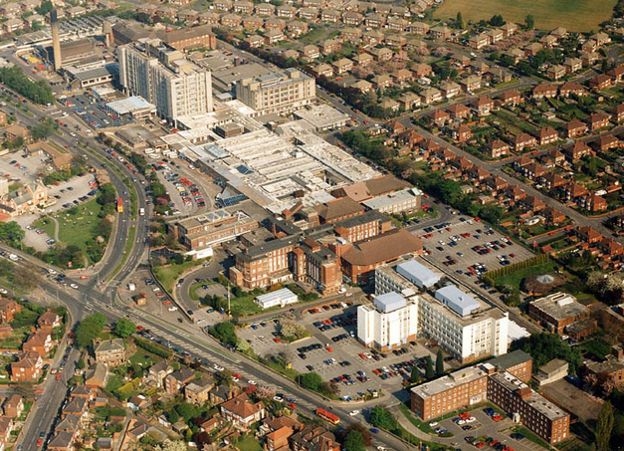
Directions
From the M1 exit at J32
take the M18 towards Hull/Doncaster
at junction3, take the A6182 exit to Doncaster
Keep going straight and
follow signs for racecourse/hospital
Park in gate 1a off Thorne Road
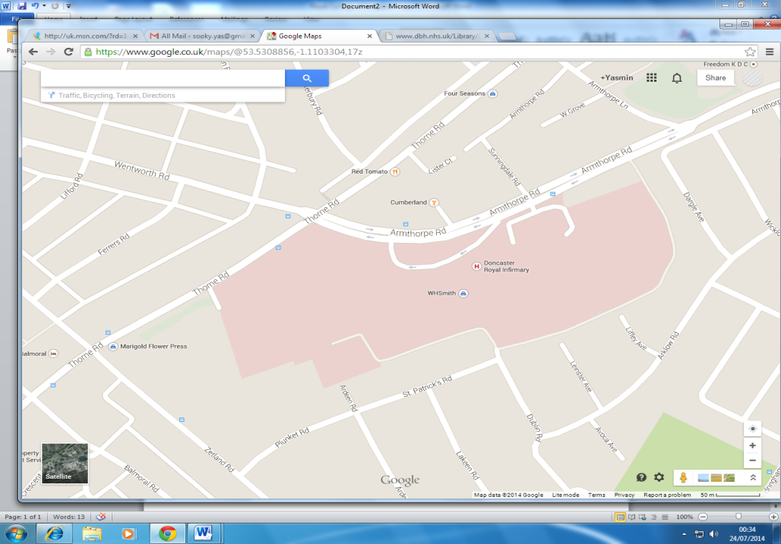
Site map: Follow signs to Education Centre

