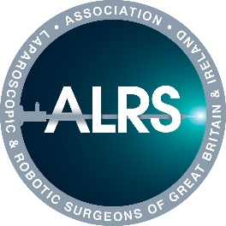
ALRSGBI RoboPass®
Wednesday 6 May 2026 at the Griffin Institute, Northwick Park & St Mark’s Hospital

Personal Details
Name
Contact Address
Email
Daytime Telephone No
Current Hospital
Current level of training (ST3- ST8/ equivalent or Fellow in General Surgery, Urology or Gynaecology or other specialty)
Current sub-specialty

Robotic experience (please send evidence via email to Jenny with the form at jtreglohan@alrsgbi.org:
Courses: please state name of the course, provider and date
Bedside assistant: number of cases
Consol experience: number of cases

Other MIS Training experience

Do you have any dietary requirements?
ALRSGBI Member Yes / No
Please return by email to Mrs Jenny Treglohan, Executive Director jtreglohan@alrsgbi.org together with evidence of VR Robotic simulation and evidence of the number of assistant robotic cases undertaken.
Closing Date: 15 April 2026. Cost: GBP 250 members, GBP 300 non-members

